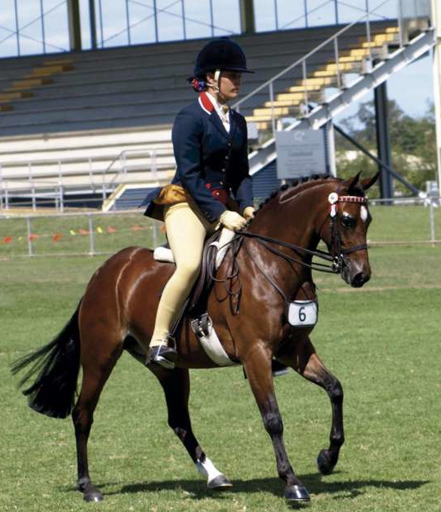
Park Melody- (Show Name)
Penny

Height - 12.3 hh Age - 6 year old & Mare
She has done a lot of showing, Dressage, hack.
She has just started show jumping and is showing a high potential to jump high. Hasn’t competed her jumping as daughter does not jump.
ROYAL CHAMPION CHILD'S SHOW HUNTER PONY. Dressage.
Won just about everything!!!!
Reg. APSB, ASPA, AHSA, RPSB, WPCS, SHC
This delightful, impeccably bred pony is very reluctantly offered for sale as the child we bought her for has lost interest!!! Sadly for her mummy another lucky child will benefit from several years of education and tlc!! Miss Penny has a superior education; she has flying changes and a SUPERLATIVE extended trot! There is not a lot left Penny has not won; She always brings home broad ribbons!! She is qualified and entered for Brisbane and Sydney Royal. Penny is affectionate and sweet, she requires no work down. Miss Penny is forward moving and will happily show all day. Penny gives the feel of riding a large horse; she is a super moving pony and has 3 truly excellent paces. The person lucky enough to score this super is young show and dressage pony will have a friend for life. Penny is available to the perfect home only as she is very loved by her owner and all at. She is ready to hop on a float and go out and win at Royal! . Call 0425 807 792 or email cindyhansen@gmail.com
